
GOVERNMENT OF KARNATAKA
VISION GROUP ON SCIENCE AND TECHNOLOGY
Karnataka Science and Technology Promotion Society
Department of Information Technology, Biotechnology and
Science & Technology

Annexure-III
- GENERAL INFORMATION

1. | Scheme Applied  (CESEM, CISEE, K-FIST L1 & L2 and RGS/F) | :
2. | About the project
a) | Title of the project | : |  | IoT-based intelligent environment that reduces latency to give an enhanced classroom experience.
b) | Subject area as per instruction  (Please refer serial No.26 under Annexure-II) | : |  | Internet of Things
3. | Details of Principal Investigator
a) | Name | :
b) | Date of Birth & Gender  (Age as on 30/10/2019) | : |  | M  F
c) | Qualification | :
d) | Designation | :
e) | Department | :
f) | Years of teaching/research experience | :
g) | Email ID | :
h) | Cell Number | :
i) | Residential Address | :
4. | Details of Co-Principal Investigator
a) | Name | :
b) | Date of Birth & Gender  (Age as on 30/10/2019) | : |  | M  F
c) | Qualification | :
d) | Designation | :
e) | Department | :
f) | Year of teaching/research experience | :
g) | Email ID | :
h) | Cell Number | :
i) | Residential Address | :
5. | Details of the Head of the Department
a) | Name of the Head of the Department
b) | Email ID | :
c) | Cell Number | :
6. | Details of the Institution
a) | Name of the College/Institution with address | :
b) | Type of the Institution (as per the instruction in Sl.No.29) | :
c) | Accredited year by NAAC/NBA | :
d) | Name of the Head of the Institution | :
e) | Designation of the Head of the Institution | :
f) | Phone Number (Landline) and college website | :
g) | Cell Number | :
h) | Email ID | :
7. | If your proposal is selected,
a) | Cheque/DD to be written in favour of | :
8. | If, amount to be credited to your bank
a) | Name of the Account holder | :
b) | Name of the Bank and Branch | :
c) | IFS Code | :
d) | SB A/c Number | :
e) | Address of the Bank | :
* Please enclose separate sheet to provide more information, if any

Passport size Photograph of Principal Investigator

Passport size Photograph of Co-Principal Investigator

Signature of the Principal Investigator Signature of Co-Principal Investigator

Signature of Head of the Signature of the Head of the
Department (with seal) Institution (with seal)

- DETAILS OF THE PROJECT PROPOSAL

1. | Title of the Project Proposal | : | IoT-based intelligent environment that reduces latency to give an enhanced classroom experience.
2. | Project Keywords | : | Smart classroom, Attendance, Automated Attendance System, Energy Optimization, Classroom Overhaul, Cloud Server Management, IoT, Learning, Energy Conservation, Sustainable, Full-proof system, Edge Computing.
3. | Objectives of the proposal  (Not more than six points) | : | - Identifying the key grey areas that result in a dormant attendance system.  - Implementation of an automated attendance systems with minimum loopholes for students to exploit.  - Estimating and reducing the average energy footprint of a classroom and hence our university, doing our part in environment preservation.  - Design a cloud-based dashboard containing a detailed analysis based on the attendance information.  - Updating the timetable dynamically based on data patterns to minimize latency and enhance learning experience.  - Intelligent fan system based on temperature, humidity and prior preferences.
4. | Background of the project | : | Irrespective of the significant advances in technology over the last decade, the conventional methods practiced in most of the institutions for attendance are by calling names or signing on papers, which is highly time-consuming and insecure. There exist many theoretical solutions for this, however reliability is a major setback.  In addition to this, it is a common sight that classroom equipment like fans and lights are left on thereby wasting considerable amount of energy.  It is observed that education institutions are responsible for major portion of electricity consumption in our country, which is a major setback for its economy.  This unchecked energy usage also puts a strain on our already dying environment.  Our attempt aims to tackle both these problems using IoT-based solutions in order to provide a better learning environment and usher the future generations into a sustainable tomorrow.
5. | Methodology  (Please include flowsheet, if required) | : | 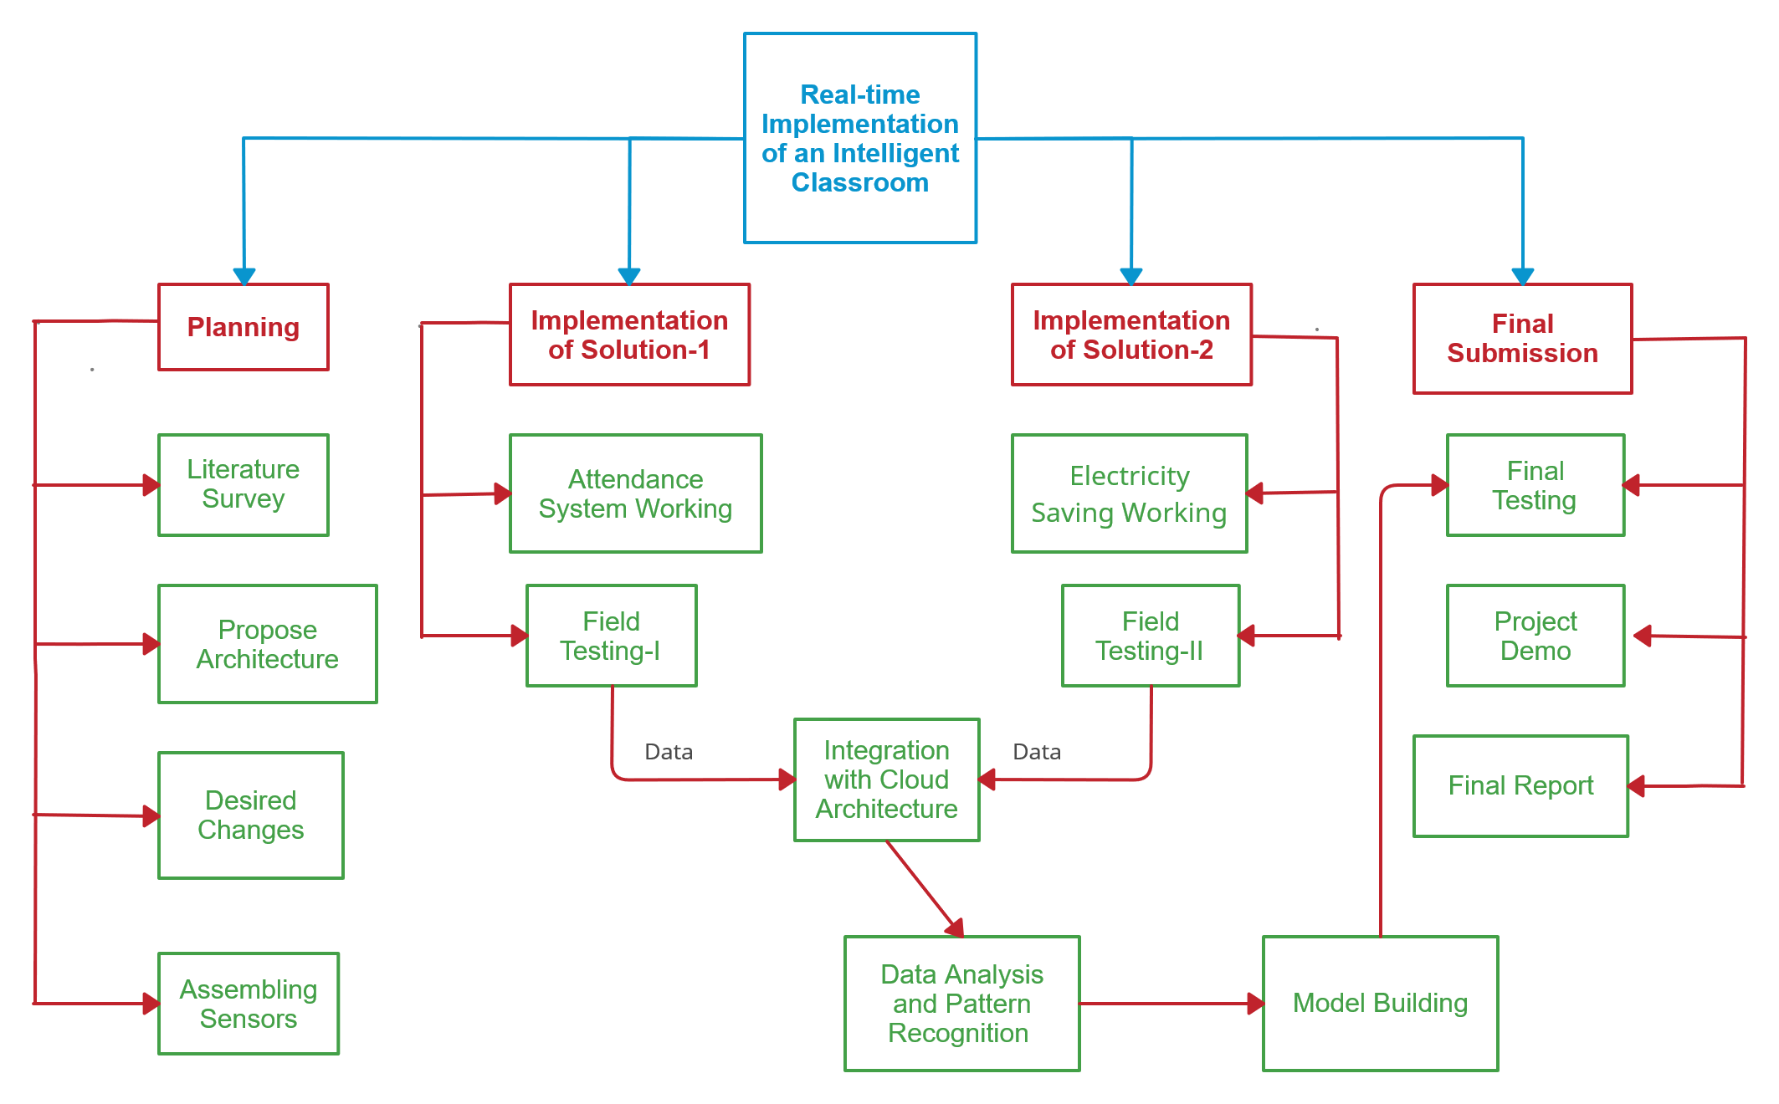
6. | Milestones with time schedule &  work plan | : | 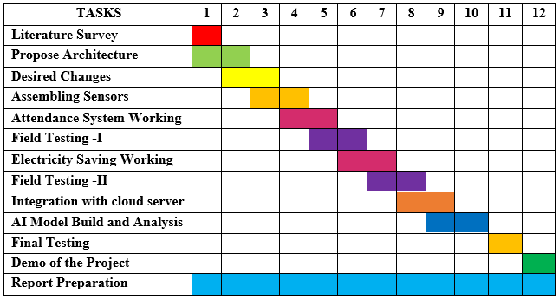
7. | List of equipment available in your Institute/College  for the project implementation | : | - Relays  - Wiring  - Fans  - Tube lights
8. | List of equipment required for Phase-I & Phase-II for Project Implementation (as per the instruction Sl.No.27 under Annexure-II) | : | - UART Capacitive Fingerprint Sensor  - Absolute Native Electronics W1209 50~100 digital temperature controller thermostat  - Tolako 5v Relay Module  - PIR Motion Detector Sensor Module HC-SR501  - Microcontroller: Raspberry Pico/ Raspberry Pi  - Transmitter and Receiver for 1km range.  - Wireless Connectivity (Wi-Fi Module)  - Server: Agile, Django/ IoT Platform like ThingSpeak  - Battery, Breadboard, etc.
9. | Relevance, importance & application  of the project | : | - The gross electricity consumption of India in 2019-20 was 1,208 kWh per capita, a huge portion of which is due to the unattended fans and lights in educational institutions.  - Our project aims to minimize this and create a sustainable solution to preserve our environment.  - Our project believes in developing a more environmentally aware and responsible generation of citizens and help every member of the education community to understand the scope and significance of the individual role in sustainable use of resources within the campus.  - Overhaul the age-old system of manual attendance in real-time in order to reduce efforts of the lecturers, increasing the active learning period. This is done keeping in mind the inadequacies of the many theoretical solutions such as RFID.  - Improved learning experience by creating a seamless, dynamic schedule that will reduce time lapses between classes and create a favourable conditions that would benefit students and teachers alike.
10. | Novelty/Uniqueness of the project  proposal | : | - Automated yet reliable attendance system that would help improve classroom learning. Fool proof solution is important keeping in mind the innovative ways students find to bypass attendance systems.  - Real-time implementation that is independent of the wiring system and hence may be extended to Government schools and colleges, in order to reduce their electricity costs.  - Reduce our country's major source of energy utilization and help increase economic growth.  - Help reduce harmful effects of unsolicited energy consumption on the environment and save our planet for future generations.
11. | Whether this project leads to innovations and patents, if yes explain | : | No
12. | Whether this project leads to a Startup, if yes explain | : | Yes  - It can be implemented and tested in real time and will lead to cost reduction.  - It will increase active learning time by reducing the efforts required by manual attendance system.  - It will lead to significant energy conservation. Remarkable reduction in the university’s energy footprint will create a sustainable environment, which can commercialize our product.
13. | Whether this project leads to cost effective Technology, if yes explain | : | Yes  - Our solution for reducing energy consumption follows the working principle of a smart A.C but at a significantly lesser cost. This also would help the college in saving huge amounts on electricity and aid the economy of our country.
14. | Additional details about the  Project, if any | :
15. | Deliverables of the project  (Precise and in bullet form) | : | - Smart Attendance System  - Automated Energy Conservation System
16. | Whether the project involves collaboration with research  Institution/Industry:  If yes, please enclose a letter to this effect | : | No
17.  a) | Other additional information:  Principal Investigator & Co-Principal Investigator | :
17.  a) | List of Publications  (For the last 5 years)  - Journal Publications listed in SCImago Journal Rank (Rating … Q1 OR Q2 OR Q3 OR Q4). Specify rating referring to the website:  https://www.scimagojr.com/journalsearch.php  - Journal publications -Not listed in SCImago  Journal rating rank  - Google Impact factor of journal  - Conference Presentations | : | (i)  1.  2.  3.  ..  (ii)  1.  2. ….…  (iii)  (iv)  1.  2. ……
b) | Books published/chapter contributed with details | :
c) | Patent (s) filed/granted with details | :
d) | Details of commercialization status for the granted patents | :
e) | Industrial consultation (given/undertaken): provide details | :
f) | Please state willingness of your Institute to give partial financial support to this proposal. If yes, state percentage of the total cost that will be supported by your Institute. Include a signed letter from the head of the institute assuring the said support | :
g) | Highlight reasons in FIVE sentences or less, what is special, unique or novel in your project that makes it an attractive proposition | : | - Automated yet reliable attendance system  - Full proof solution  - Real time Implementation  - Reduce harmful effects of unsolicited energy consumption.

- UNDERTAKING FROM THE PRINCIPAL INVESTIGATOR AND CO-PRINCIPAL INVESTIGATOR

Project Title: ______________________________________________________________________________________________________
VGST Scheme: _____________________

1) We have carefully read the terms and conditions of VGST Scheme and we
agree to abide by them and complete the project by fulfilling all the formalities.

2) We have not submitted or obtained any financial support for this or a similar
project proposal.

3) We shall ensure that the equipment shown in the project proposal which will
be procured under this project are not available in our institution/college.

4) The equipment procured under VGST Scheme will be made available to other
faculty and students, as needed by them.

Name and Signature of the Name and Signature of
Principal Investigator Co-Principal Investigator

Date:

- ENDORSEMENT FROM HEAD OF THE COLLEGE/INSTITUTION (ON THE OFFICIAL LETTERHEAD)

Project Title: ______________________________________________________________________________________________________
VGST Scheme: ____________________

- Certify that the College/Institution welcomes the participation of Dr./Mr./Mrs…………………………. as the Principal Investigator and Dr./Mr./Mrs………………………as the Co-Principal Investigator for the project, and that in the unforseen and legitimate event of discontinuation by the Principal Investigator, the Co-Principal Investigator will accept/take full responsibility for completion of the project. Information to this effect, endorsed by me, will be promptly sent to VGST.

- Certify that the Laboratory equipment and adminitrative facilities will be made available to the Investigators throughtout the duration of the project.

- The College/Institution will take the responsibility of all the financial and purchase procedures as per the prevailing Government norms within the allocated and approved budget.

- The College/Institution shall provide timely statements of expenditure and utilization certificates of the funds received under this project/scheme in the prescribed format.

Date: Signature of the Head of the
Institution

Annexure-IV

APPLICATION FOR THE
AWARD FOR RESEARCH PUBLICATIONS (2019-20)
(The previous ARP awardees are not eligible to apply once again for ARP scheme)
(INFORMATION OF THE APPLICANT & INSTITUTION)

1. |  | Name of the Applicant
2. |  | Date of Birth & Gender  (Age as on 30/10/2019) | M F
3. |  | Educational Qualification
4. |  | Designation
5. |  | Name of the Department
6. |  | Name of the Institution and address
7. |  | Type of Institution as per instruction
8. |  | Teaching Experience (Years)
9. |  | Research Experience (Years)
10. |  | Contact details of the Applicant | Residential  Address
 |  | Contact details of the Applicant | E-mail
 |  | Contact details of the Applicant | Cell No.
 |  | Contact details of the Applicant | Landline Phone No.
 | DETAILS OF RESEARCH PUBLICATIONS

1. | Broad Areas of Research
2. | Focused Area of Research
3. | Total No. of Publications
4. | List of Publications  (For the last 5 years)  - Journal Publications listed in SCImago Journal Rank (Rating … Q1 OR Q2 OR Q3 OR Q4). Specify rating referring to the website: https://www.scimagojr.com/journalsearch.php  - Journal publications -Not listed in SCImago  Journal rating rank  - Google Impact factor of journal  - Conference Presentations | (i)  1.  2.  3.  ..  (ii)  1.  2. ….…  (iii)  (iv)  1.  2. ……
5. | Details not more than three best Research Publications which are to be considered for this award.  (Enclose copies)
6. | Publications/periodicals etc. wherein the research  work has been referred to or referenced. Please give citation index of the contribution, using google scholar data.
7. | Enclose a complete list of publications giving details  of reputed Journals in which they are published  (Please refer to the web, mention the journal name, index)
8. | Any other information of academic / technical in nature about the research publications that you have listed in item no.4 in support of the application/ nomination (limit: 100 words)
9. | Provide details if you have generated any patents, products out of your research publications.

Passport size Photograph

Name & Signature Name & Signature of the
of the Applicant Head of the Institution (with Seal)

Date:
Place:

ANNEXURE- V

SCHEME: FACULTY DEVELOPMENT PROGRAMME (FDP)

1. | Title of the Programme (FDP)
2. | Name and Address of the College/Institute
a) | College/Institute Email Id:
b) | Website
c) | College/Institute Landline Number
3. | Name of the Principal Programme Coordinator
a) | Qualification
b) | Gender
c) | Designation & Department
d) | Years of Teaching/Research/Industry Experience
e) | Email ID
f) | Cell Number
g) | Residential Address
4. | Name of the Co-Principal Programme Coordinator
a) | Qualification
b) | Gender
c) | Designation & Department
d) | Year of Teaching/Research/Industry Experience
e) | Email ID
f) | Cell Number
g) | Residential Address
5. | Designation of the Head of the Institution
6. | If Your Proposal is selected, the Cheque/DD to be written in favour of
7. | Please provide the bank account details for which the amount to be credited
a) | Name of the Account holder
b) | Name of the Bank
c) | The Branch Address
d) | IFS code
e) | SB A/c Number

8) DETAILS OF THE FACULTY DEVELOPMENT PROGRAMME (FDP):
a) | Title of the Programme:
b) | Keywords
c) | Objectives of the Programme:
d) | Relevance of the Programme/Topic:
e) | Background of the Programme with respect to teaching methodology/Research:
f) | Similar Events organised by the Institute on this subject, if any:
g) | Please provide list of Resource persons with details.
h) | Proposed dates for the Programme:
i) | Additional Details of the Programme, if any:

- DETAILS OF THE INDUSTRIAL COLLABORATION:

a) | Name of the Industry
b) | Type of Industry:
c) | Postal Address of the Industry:
d) | Industry Email ID:
e) | Website:
f) | Landline Number:
g) | Name(s) of the Contact person:
h) | Designation:
i) | Technical Expertise:
j) | Financial Commitment if any:
k) | Role of the Industrial Collaboration in the programme:

10) Similar event organized by the Institute earlier, if any.

Title of the activity | Subject | Date from to  (latest first) | Level  (Regional/National/  International) | Name of external body involved, if any | Grants received by funding agency (Rs.)

11) Budget Estimates

Details of Expenditure | Anticipated Expenditure  (a) | Budget Contribution by Organizing Institute.  (b) | External Sponsorships  (Industry)  (c) | Total  (a+b+c)
Travel and Honorarium for Resource Persons
TA & Accommodation (outstation) and Food for Participants
Conference preparation and arrangements

Miscellaneous
Total
Grand Total (a+b+c)

Note:
- Please submit the detailed report within a month after completion of the Programme.

- Submit Utilization Certificate (UC) duly authenticated by CA at the time of submitting the report.

- Return unutilized grant amount with accrued interest to “Managing Director, KSTePS, Bengaluru”.

- Faculty Development Programme should be organized within 6 months after receiving the grant in collaboration with industries. The maximum budget allocated for each FDP is of Rs.2.00 lakh only from VGST.

- If the Programme Coordinator leaves the Institution, the FDP will have to be conducted by the Co-Programme coordinator.

Passport size Photograph of the Principal Programme Co-ordinator

Passport size Photograph of the Co-Principal Programme Co-ordinator

Signature of the Signature of the
Principal Programme Coordinator Co-Principal Programme Coordinator

Signature of the Head of the Signature of the Head of the
Department (with seal) Institute (with seal)

Date:
Place:

- ENDORSEMENT FROM HEAD OF THE COLLEGE/INSTITUTION (ON THE OFFICIAL LETTERHEAD)

FDP Title: ______________________________________________________________________________________________________
- Certify that the College/Institution welcomes the participation of Dr./Mr./Mrs…………………………. as the Principal Programme Co-ordinator and Dr./Mr./Mrs………………………………as the Co-Principal Programme Co-ordinator for the programme and that in the unforseen and legitimate event of discontinuation by the Principal Programme Co-ordinator, the Co-Principal Programme Co-ordinator will take full responsibility for completion of the programme.
- Certify that the Laboratory equipment and adminitrative facilities will be made available to the Co-ordinators throughtout the duration of the programme.
- The College/Institution shall provide timely the statement of expenditure and utilization certificate of the funds received under this programme/scheme in the prescribed format.

Date: Signature of the Head of the
Institution

TENTATIVE SCHEDULE

“FACULTY DEVELOPMENT PROGRAMME FOR ENGINEERING COLLEGE (FDP-ENGG)” DURING THE FY: 2019-20

Title of the proposed program under FDP:

Venue:

Day 1:
TIME | PROGRAMME
9.00 am – 10.00 am | Inauguration
10.00 am – 11.30 am | Lecture 1 by Resource Person
11.30 am – 11.45 am | Tea/Coffee Break
11.45 am – 01.15 pm | Lecture 2 by Resource Person
1.15 pm -2.15 pm | Lunch Break
2.15 pm – 3.45 pm | Lecture 3 by Resource Person
3.45 pm – 4.00 pm | Tea/Coffee Break
4.00 pm – 5.30 pm | Lecture 4 by Resource Person

Day 2:
TIME | PROGRAMME
10.00 am – 11.30 am | Lecture 5 by Resource Person
11.30 am – 11.45 am | Tea/Coffee Break
11.45 am – 1.15 pm | Lecture 6 by Resource Person
1.15 pm -2.15 pm | Lunch Break
2.15 pm – 3.45 pm | Lab Session with Resource Experts
3.45 pm – 4.00 pm | Tea/Coffee Break
4.00 pm – 5.30 pm | Lecture 7 by Resource Person

Day 3:
Name(s) of proposed Industries / R & D Institutions to be visited:
TIME | PROGRAMME
9.00 am – 5.30 pm | Visit to nearby Industries / Factories,  R & D Institutions:  The timings of lecture, lunch break etc., can be arranged based on the convenience of the collaborating/ organizing Industries /Institutions.

Day 4:
TIME | PROGRAMME
9.30 am – 11.00 am | Lecture 8 by Resource Person
11.00 am – 11.15 am | Tea/Coffee Break
11.15 am – 12.45 pm | Lecture 9 by Resource Person
12.45 pm – 1.30 pm | Lunch Break
1.30 pm – 3.00 pm | Lab Session with Resource Experts
3.00 pm – 4.30 pm | Lab Session with Resource Experts
4.30 pm – 5.30 pm | Valedictory Function & High Tea

VGST – FDP - ENGG: 2019-20
TENTATIVE ESTIMATE OF EXPENDITURE
(Guidelines)

Sl. No. | Particular/Head | Amount  in Rs.
1 | Travelling Allowance for outstation participants including to and fro and internal/local transport | 20,000/-
2 | Food and Accommodation (wherever applicable) for participants | 60,000/-
3 | Travel, Honorarium for Experts | 50,000/-
4 | Folders, Pens, Work books, Stationary, Badge, Brochures, Certificate, Resource Material for 50 Persons @Rs. 200 per person | 10,000/-
5 | Inauguration, Valedictory function: Banner, Invitation, Publicity, Media, Courier, Postal, Telephone, Documentation & Coordination Expenses. | 20,000/-
6 | Contingency fund | 10,000/-
7 | Local transport to Industrial Visit & Coordination | 15,000/-
8 | Honorarium to supporting Staff @ Rs. 500/day for 3 persons for 4 days (500x3x4 days) | 7,000/-
9 | Honorarium for the Chief Co-Ordinator of FDP | 8,000/-
Total amount allocated for organizing 4 days FDP |  | 2,00,000/-

PS:
- Minimum participants shall be 50, out of which 40 shall be from other colleges.
- Only 10% of re-appropriation in the Estimated Expenditure under each head is allowed.
- Air fare for Resource persons is not allowed from VGST grants. However, this can be arranged through grants from Parent organization or External agencies.
- Institution and Industrial support are encouraged besides VGST grants.

